**Directions:** Using the four prompts below, identify how the FoodieLand app demonstrates good UX design.

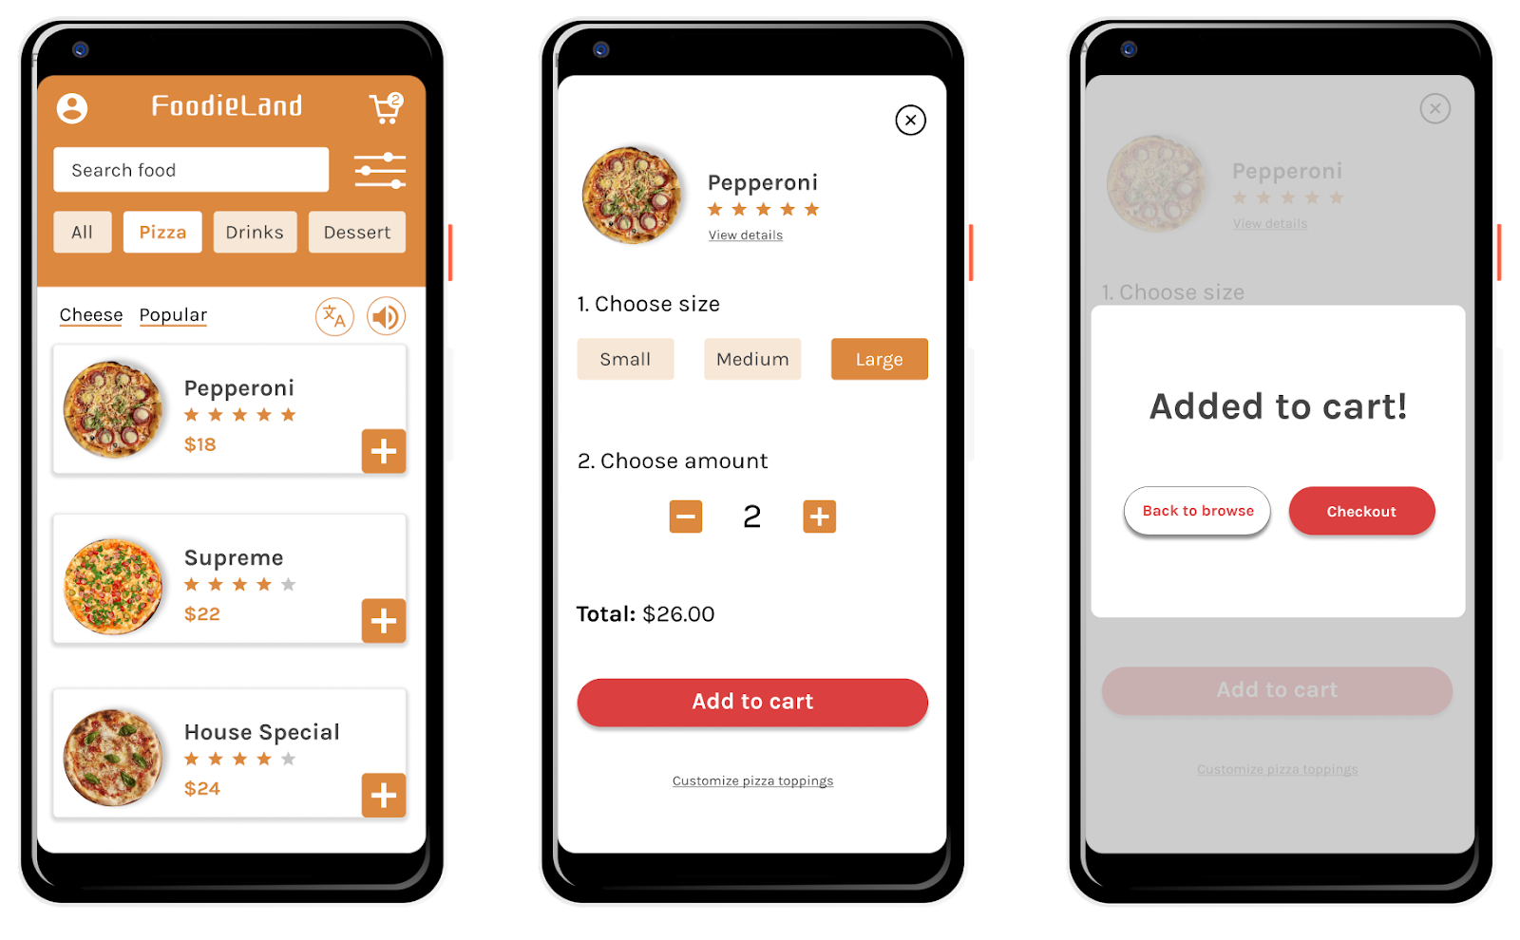

Prompt 1: Identify at least one aspect of the FoodieLand app that demonstrates usable design. Explain your reasoning in 1-2 sentences.

| Hint: Is the app’s design, structure, and purpose clear? Does the app have any elements or features that make it easy to navigate? | | |
| --- | --- | --- |

| **Usable** | Permite acessar o carrinho, selecionar filtros, busca por um sabor, calcula o valor automaticamente |
| --- | --- |

## 

## Prompt 2: Identify at least one aspect of the FoodieLand app that demonstrates equitable design. Explain your reasoning in 1-2 sentences.

| Hint: Does the app address the needs of people with diverse abilities and backgrounds? | | |
| --- | --- | --- |

| **Equitable** | Possui ícone de tradução e permite ouvir em áudio os sabores |
| --- | --- |

## 

## Prompt 3: Identify at least one aspect of the FoodieLand app that demonstrates enjoyable design. Explain your reasoning in 1-2 sentences.

| Hint: Does the app inspire a positive reaction from the user by considering their thoughts and feelings? Does the app engage users and make them excited to keep using the app? | | |
| --- | --- | --- |

| **Enjoyable** | Segue uma linha de cores, padrão, os ícones também possuem um tema definido |
| --- | --- |

## 

## Prompt 4: Identify at least one aspect of the FoodieLand app that demonstrates useful design. Explain your reasoning in 1-2 sentences.

| Hint: Does the app solve the problem of “how to help a busy person working from home select a meal to be delivered?” How does the app help solve this problem? | | |
| --- | --- | --- |

| **Useful** | É um app agradável, possui diversos recursos não encontrados em outros apps |
| --- | --- |